1. Pull-up resistor

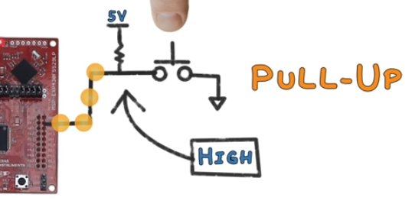

When button is pushed, the input pin reads “Low”.

When not pushed, it reads “High”.

***Question: Why don’t we just connect the pin directly to power source?***

1. Latch: a device with exactly 2 stable states. A latch has a feedback path, so information can be retained by the device. So, it can store 1 bit of data for as long as the device is powered.